５

★献金に対する２つの大きなイベント。
②スタートしています！
100倍の祝福⇒教会員、MCリーダー、牧師を通して多くの人々を祝福する。

２０２１年１０月０３日
『自分を捨て、自分の十字架を負って』
Deny Himself and Take Up His Cross
マルコ Mark ８：３４～３８

- ペテロへ、下がれ≪後に≫サタンTo Peter, get behind me, Satan!

- 群衆と弟子たちを呼んで語られた
call and speak to the crowd to and his disciples

- イエス様に従って≪後に付いていく≫いきたいと思う者
If anyone would come after me

- 『自分を捨て、自分の十字架を負って』の意味deny himself and take up his cross

- イエス様が私に何をして下さったか？What did Jesus do for me?

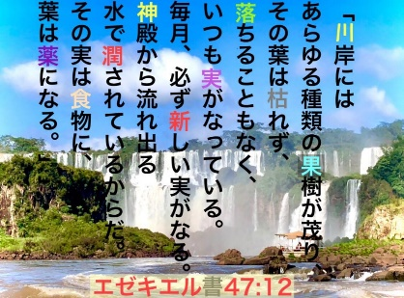
- キリストと福音伝道のためにMy sake and for the gospel will save it

