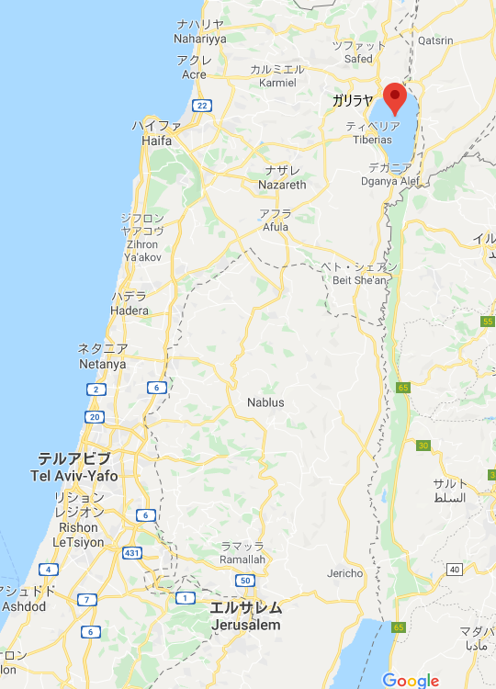

２０２０年０５月１７日
By Suzuki
『権威ある教えと悪霊からの解放』
The Authority Of Jesus and Jesus Expels an Unclean Spirit
マルコMark１：２１－２８

- カペナウムに行かれた They went to Capernaum

- さっそく教え始められた immediately he was teaching

- 権威ある教え teaching by one who had authority

- 律法学者の教えのようでなく not as the scribes

- 汚れた霊 unclean spirit

- 悪霊を追い出す Cast out evil spirits

コメントを書く Comments

